
MATHEMATICS SPECIALIST 3,4
TEST 3 SECTION ONE 2016
NON Calculator Section
Chapters 4,5

Name________________________________ Time: 15minutes
Total: 13 marks
Question 1 [5 marks]

The diagram to the right shows parallelogram ABCD where 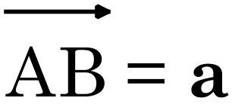 and .
Point X divides DB internally in the ratio 2:1.
Point M is the midpoint of AB.

- Show that 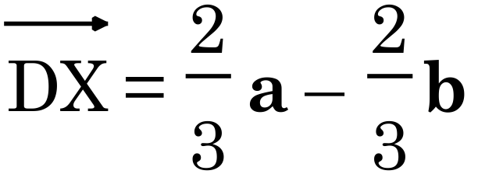 . [1]

- Find  in terms of a and b. [1]

- Prove that points M, X and C are collinear. [3]

Question 2 [6 marks]

Given the vectors, a = 2i – 3j + k, b = 4j – k and c = i – 2j – 3k, find:
a) 3b – a [1]
b) ⏐c⏐ [1]
c) the vector equation of the line passing through the point with position vector 3b and
the point with position vector a. [2]

d) the vector equation of the plane passing through the point with position vector b
and normal to the vector c. [2]

Question 3 [2 marks]

Find given that

